Design: Half Hourly Report Transmission to NEWSWIRE

Overview

Current processing
New functionality.

New requirement
CBOE needs to send report to NewsWire(NW) every half an hour. MarketDataReportService is used to gather the data. This service creates a struct called OptionsHalfHourlyReportStruct. Half hourly report for NewsWire is created from this struct. Also, OptionsHalfHourlyReportStruct is used to create the reports for OPRA and HVOL.
The Half Hourly Report for NewsWire includes following details:
- Half an hourly volume for calls and puts by category
- Half an hourly volume for total calls and total puts
- Gainers and Losers for calls and puts by category
- Gainers and Losers for total calls and total puts
- Overall Most Active Calls and Most Active Puts by each category
- Most Active Call Series (Top ten) and Put Series
The transmission will start at 7:30:00 and ends at 15:30:00 with time interval of 30:00 min between each report. The reports generated will be cumulative. Training class and industry test class (if any) have to be excluded while calculating total volume for Equity, Composite and Index category. The system should have functionality to configure start and end time for the reports. The transmission should be aborted at 16:30:00 e.g. if the computation time for the last report i.e. 15:30:00 crosses 16:30:00 due to some problem the transmission should be aborted. No reports will be sent after 16:30:00. The system should have functionality to abort, retransmit, terminate the report processing.
The reports must be in XML format and must be FTPed to the NW.

Scope
Scope of this design document is limited to formatting & sending report to NewsWire from the pre-populated OptionsHalfHourlyReportStruct. The generation of OptionsHalfHourlyReportStruct will be implemented in SPRINT 2. In Sprint 1 values will be hard coded.

Assumptions
XML report will be sent to NewsWire and there would be no story format.

Implementation
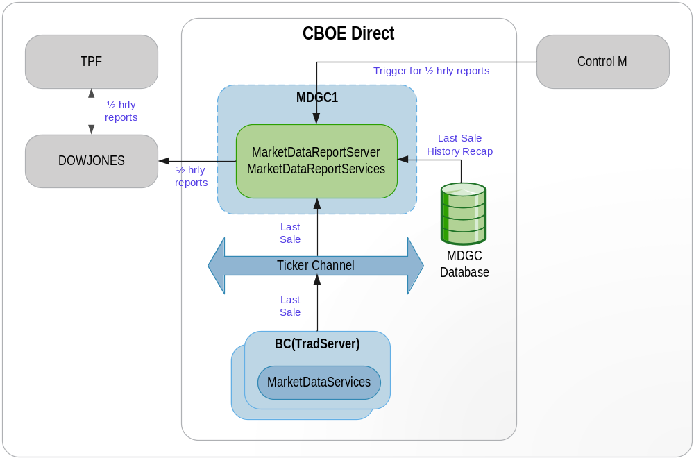

- Half Hourly Report For NewsWire Flow
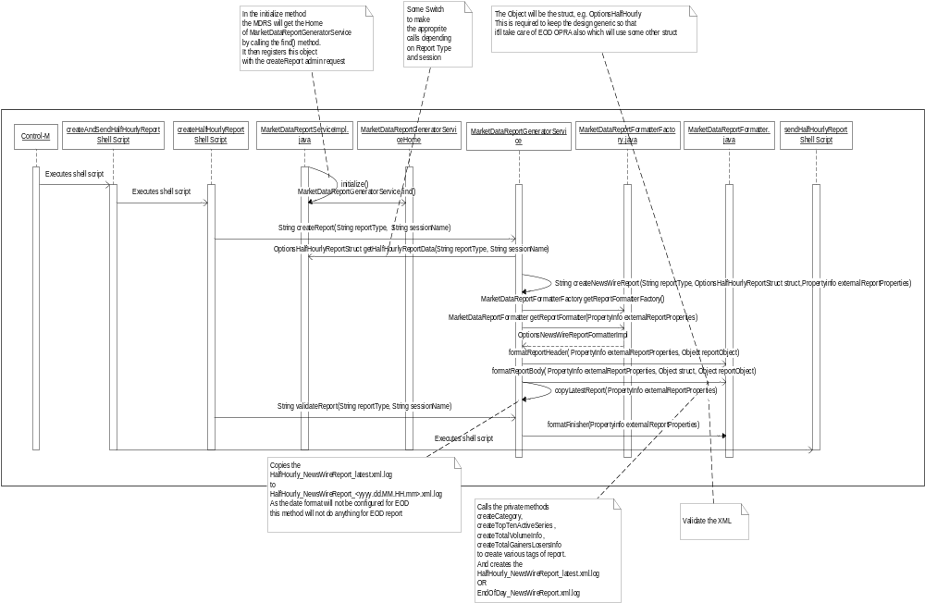

- MarketDataReportGeneratorService is a different service running on MarketDataReportServer. This service is responsible for formtting of different kind of reports.
- MarketDataReportService calls the find() method of MarketDataReportGeneratorServiceHome which returns the object of MarketDataReportGeneratorService. It registers this object with the ar command ‘createReport’ in the initialize method.
- Control-M executes createAndSendHalfHourlyReport/ createAndSendEODReport shell script that takes the following parameters
  - Report Type
  - Session Name – W_MAIN (e.g.)
Report Type | Parameter 1 (Report Type) Value | Parameter 2 (Session Name) Value
HALF_HOURLY_NEWS_WIRE | 2 | W_MAIN
END_OF_DAY_NEWS_WIRE | 4 | W_MAIN
HALF HOURLY_NW _HVOL | 25 | W_MAIN

- This shell script invokes the createHalfHourlyReport shell script passing the parameters.
- createHalfHourlyReport shell script call the ar command ‘createReport’ which calls ‘createReport’ method of MarketDataReportGeneratorService.
- createReport method of MarketDataReportGeneratorService calls back the MarketDataReportService to get the OptionsHalfHourlyStruct depending on the reportType (For reportType - 1,2,4,12). For this, createReport method of MarketDataReportGeneratorService calls find method of MarketDataReportServiceHome which returns the object of MarketDataReportService. On this object, it calls getHalfHourlyReportData method of MarketDataReportService. This method creates the OptionsHalfHourlyReportStruct and returns the struct. Half hourly NewsWire Report, EOD NewsWire Report and Half Hourly OPRA report will be created from this struct. However, the EOD report to OPRA will be created from another struct.
- It then creates the Propertyinfo info for that session and report type.
- createReport method of MarketDataReportGeneratorService then calls the private method createNewsWireReport passing the reportType, OptionsHalfHourlyReportStruct and Propertyinfo info for that session.
- createNewsWireReport calls the static method getReportFormatterFactory of MarketDataReportFormatterFactory. This returns the object of MarketDataReportFormatterFactory. It then calls getReportFormatter method on this object which returns the implementation class of MarketDataReportFormatter interface depending on the report type. In this case it will return the object of OptionsNewsWireReportFormatterImpl.java.
- On this object, it calls formatReportHeader method which creates the report header.
- After creating the header, it calls the formatReportBody of MarketDataReportFormatter passing the OptionsHalfHourlyReportStruct as Object type.
- formatReportBody creates the body of the report by calling private methods createCategory, createTopTenActiveSeries , createTotalVolumeInfo , createTotalGainersLosersInfo to create various tags of report. It stores the xml to the disk with name HalfHourly_NewsWireReport_latest.xml.log OR EndOfDay_NewsWireReport.xml.log depending on the Properties set.
- Then it calls the copyLatestReport that copies the HalfHourly_NewsWireReport_latest.xml.log to HalfHourly_NewsWireReport_<yyyy.dd.MM.HH.mm>.xml.log. As the date format will not be configured for EOD, this method will not do anything for EOD report.
- createHalfHourlyReport shell Script then calls ar command validateReport. This call to ar command can be disabled if required.
- validateReport then calls validateReport method of MarketDataReportGeneratorService.
- validateReport then calls private method validateReports which then calls the static method getReportFormatterFactory of MarketDataReportFormatterFactory. This returns the object of MarketDataReportFormatterFactory. It then calls getReportFormatter method on this object which returns the implementation class of MarketDataReportFormatter interface depending on the report type. In this case it will return the object of OptionsNewsWireReportFormatterImpl.java.
- validateReports then calls formatFinisher on the object of OptionsNewsWireReportFormatterImpl.java. This method validates the newly created XML against the configured XSD.

Alternate Flow: Resend report
- If because of some reasons the report is not FTPed , it has to be resent.
- The sendHalfHourlyReport shell script needs to be called which will call the sendReport shell script passing the file name ‘HalfHourly_NewsWireReport_latest.xml.log’ for the script to ftp it.

Alternate Flow: Abort/Terminate Transmission
- To abort / terminate the transmission of report if the time of transmission crosses certain time, system time will be checked in the sendReport script before actually sending out the report.
- To abort / terminate the transmission of report from CBOEDirect, a disableNewsWireTransmission flag will be checked (flag is set to true in setContext.main in MDRS section) in the sendHalfHourlyReport script before actually calling the sendReport shell command.
2. IDL Changes
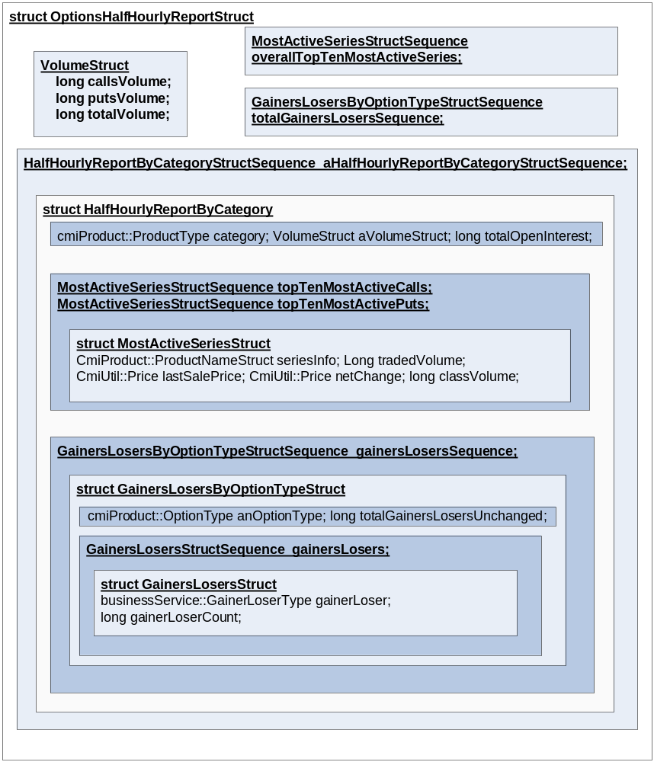

To achieve the creation and transmission functionality following idl’s must be modified

marketDataReportService.idl
Location - /vobs/dte/server/idl

typedef char GainerLoserType;

interface GainersLosersTypes
{
const GainerLoserType GAINER = 'G';
const GainerLoserType LOSER = 'L';
const GainerLoserType UNCHANGED = 'U';
};
struct VolumeStruct
{
long callsVolume;
long putsVolume;
long totalVolume;
};

struct GainersLosersStruct
{
businessService::GainerLoserType gainerLoser;
long gainerLoserCount;
};
typedef sequence < GainersLosersStruct> GainersLosersStructSequence;

struct GainersLosersByOptionTypeStruct
{
cmiProduct::OptionType anOptionType;
GainersLosersStructSequence gainersLosers;
long totalGainersLosersUnchanged;
};
typedef sequence <GainersLosersByOptionTypeStruct>GainersLosersByOptionTypeStructSequence;

struct MostActiveSeriesStruct
{
cmiProduct::ProductNameStruct seriesInfo;
long tradedVolume;
cmiUtil::PriceStruct lastSalePrice;
cmiUtil::PriceStruct netChange;
long classVolume; // This is added for HVOL
};
typedef sequence < MostActiveSeriesStruct> MostActiveSeriesStructSequence;

struct HalfHourlyReportByCategoryStruct
{
cmiProduct::ProductType category;
VolumeStruct aVolumeStruct;
long totalOpenInterest; // This is added for HVOL
GainersLosersByOptionTypeStructSequence gainersLosersSequence;
MostActiveSeriesStructSequence topTenMostActiveCalls ; // This is added for HVOL
MostActiveSeriesStructSequence topTenMostActivePuts ; // This is added for HVOL
};
typedef sequence < HalfHourlyReportByCategoryStruct> HalfHourlyReportByCategoryStructSequence ;

struct OptionsHalfHourlyReportStruct
{
cmiUtil::DateTimeStruct generationTime;
VolumeStruct totalVolumeStruct;
GainersLosersByOptionTypeStructSequence totalGainersLosersSequence;
HalfHourlyReportByCategoryStructSequence aHalfHourlyReportByCategoryStructSequence;
MostActiveSeriesStructSequence overallTopTenMostActiveSeries;
};

3. Interfaces and Classes
Interfaces:
- com.cboe.interfaces.businessServices.MarketDataReportGeneratorServiceHome.java : Add the following methods
- find
- create

- com.cboe.interfaces.businessServices.MarketDataReportGeneratorService.java : Add the following methods
- String createReport(String reportType, String sessionName)

- com.cboe.interfaces.businessServices. MarketDataReportFormatter.java:
- public void formatReportHeader(Propertyinfo externalReportProperties, Object reportObject ) throws
SystemException;
Creates the report header

- public void formatReportBody(Propertyinfo externalReportProperties, Object struct, Object reportObject) throws SystemException;
Creates the report body.

- public void formatFinisher(Propertyinfo externalReportProperties) throws SystemException;
Validates the report
- com.cboe.interfaces.businessServices.ReportConstants.java class.
- Contains all the constants to create XML tags
- Contains all the constants for report type
Report Type | Value
HALF_HOURLY_OPRA | 1
HALF_HOURLY_NEWS_WIRE | 2
END_OF_DAY_NEWS_WIRE | 4
HVOL | 5
HALF HOURLY_NW_HVOL | 25

Classes:
- com.cboe.businessServices.marketDataReportService.MarketDataReportGeneratorServiceHomeImpl.java
- find: returns the MarketDataReportGeneratorService object
- create: creates and returns the MarketDataReportGeneratorService object
- goSlave
- goMaster
- initialize: Loads the properties from the MarketDataReportGeneratorService.xml file

- com.cboe.businessServices.MarketDataReportGeneratorServiceImpl.java : Add the following methods
- String createReport(String reportType, String sessionName)
createReport method of MarketDataReportGeneratorService calls back the MarketDataReportService to get the OptionsHalfHourlyStruct depending on the reportType (For reportType - 1,2,4,12). For this, createReport method of MarketDataReportGeneratorService calls find method of MarketDataReportServiceHome which returns the object of MarketDataReportService. On this object, it calls getHalfHourlyReportData method of MarketDataReportService. This method creates the OptionsHalfHourlyReportStruct and returns the struct. Half hourly NewsWire Report, EOD NewsWire Report and Half Hourly OPRA report will be created from this struct. However, the EOD report to OPRA will be created from another struct. It then creates the Propertyinfo info for that session. createReport method of MarketDataReportGeneratorService then calls the private method createNewsWireReport passing the reportType, OptionsHalfHourlyReportStruct and Propertyinfo info for that session.

  - String validateReport(String reportType, String sessionName)
This method validates the created XML file with XSD.

  - String releaseReportGenerationLocks()
This files releases the locks for creation of Reports.

- com.cboe.businessServices.marketDataReportService.MarketDataReportServiceImpl.java
- void initialize()
MarketDataReportService calls the find() method of MarketDataReportGeneratorServiceHome which returns the object of MarketDataReportGeneratorService. It registers this object with the ar command ‘createReport’ in the initialize method.
MarketDataReportGeneratorService is a different service running on MarketDataReportServer. This service is responsible for generation of different kind of reports.

- OptionsHalfHourlyReportStruct getHalfHourlyReportData (String reportType, String sessionName)
This method creates the OptionsHalfHourlyReportStruct and returns the struct.

- com.cboe.businessServices.marketDataReportService.externalReports. MarketDataReportFormatterFactory.java :
This is the class is the factory that will return the object of implementations of MarketDataReportFormatter for formatting reports for different report types. This implementation classes is specified in MarketDataReportGeneratorService.xml.
- public static MarketDataReportFormatterFactory getReportFormatterFactory ()
This is a static method which returns the object of MarketDataReportFormatterFactory which will be singleton.
- public MarketDataReportFormatter getReportFormatter (Propertyinfo externalReportProperties)
This method returns the object of implementation of MarketDataReportFormatter.java depending on the reportType.

- com.cboe.businessServices.marketDataReportService.externalReports. MarketDataReportFormatterBase.java:
This is an abstract class that all the classes implementing the MarketDataReportFormatter interface will extend. All the common functionalities will be put in this class.

- com.cboe.businessServices.marketDataReportService.externalReports. OptionsNewsWireReportFormatterImpl.java:
This class implements MarketDataReportFormatter interface and extends MarketDataReportFormatterBase. This class implements the method required to create Half Hourly & EOD report for NewsWire.
- public void formatReportHeader(Propertyinfo externalReportProperties) throws SystemException
Creates the report header
- public void formatReportBody(Propertyinfo externalReportProperties) throws SystemException
This method gets the OptionsHalfHourlyReportStruct and creates the XML file from OptionsHalfHourlyReportStruct and stores it to disk. DOM parser will be used to create the XML file.
HalfHourly_NewsWireReport_latest.xml.log
OR
EndOfDay_NewsWireReport.xml.log

Where HalfHourly/EndOfDay & NewsWireReport is a constant specified in MarketDataReportGeneratorService.xml that is appended to all the reports
The HalfHourly_NewsWireReport_latest.xml.log /EndOfDay_NewsWireReport.xml.log will be over-written with this new file object.
- formatFinisher(Propertyinfo externalReportProperties) throws SystemException
Validates the XML with DTD

Logging
Informative messages will be logged at the beginning and end of each important method.

Exception Handling
All the exceptions will be propagated to the top level i.e. the method that is called from the ar command. This method will then log the exceptions (Log.exception) and return appropriate status from the method.

Scripts(2)

createAndSendHalfHourlyReport
This shell calls the createHalfHourlyReport shell script followed by sendHalfHourlyReport
shell script.

createHalfHourlyReport
This is a wrapper script for the admin request to createReport which would create and returns OptionsHalfHourlyReportStruct, format the XML and store it to disk.

sendHalfHourlyReport
For NewsWire this shell script will check the disableNewsWireTransmission flag is set to true in setContext.main in MDRS section and then call the sendReport to ftp the HalfHourly_NewsWireReport_latest.xml.log report generated to the NewsWire. By default, when this switch is not defined, the report will be ftped.

The following variable will be set in the script
- Last report transmission time (16.30)

createAndSendEODReport
This shell calls the createEODReport shell script followed by sendEODReport
shell script.

createEODReport
This is a wrapper script for the admin request to createReport which would create and serialize OptionsHalfHourlyReportStruct, format the XML and store it to disk.

sendEODReport
For NewsWire this shell script will check the disableNewsWireTransmission flag is set to true in setContext.main in MDRS section and then call the sendReport to ftp the EndOfDay_NewsWireReport.xml.log report generated to the NewsWire. By default, when this switch is not defined, the report will be ftped.

The following variable will be set in the script
- Last report transmission time (16.30)

sendReport
This script ftps the HalfHourly_NewsWireReport_latest.xml.log or EndOfDay_NewsWireReport.xml.log file to the NewsWire depending on the paramert passed to it. FTP is run in verbose mode and the output is redirected to NW_FTP.log.

The following variable will be set in the script
- Destination Host & Port of the NewsWire box
- FTP user and password
- folder where the XML is placed

Database(.5)
None

SetContext(.125)
None

XML/DTD(.5)

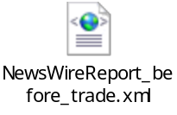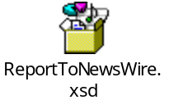
Snippet of MarketDataReportGeneratorService.xml
<Session name="W_MAIN">
<SessionProperties>
<sessionName>W_MAIN</sessionName>
<listOfExternalReports> W_MAIN_2, W_MAIN_4</listOfExternalReports>
</SessionProperties>
</Session>

<ExternalReport name="W_MAIN_2">
<ExternalReportProperties>
<ReportDir>&lt;prefixNWReportDir &gt;</ReportDir> <!—set in setContext.main under setMarketDataReportServerArgs e.g. /sbt/test5/tradeeng/run_dir/log →
<ConstantReportNameSuffix>latest</ConstantReportNameSuffix>
<ReportNamePrefix>HalfHourly</ReportNamePrefix>
<ReportName>NewsWireReport</ReportName>
<ReportExtension>.xml.log</ReportExtension>
<ReportFormatterImpl>com.cboe.businessServices.marketDataReportService.externalReports.HalfHourlyNewsWireReportFormatter</ReportFormatterImpl>
<dateFormat>yyyy.dd.MM.HH.mm</dateFormat>
<DtdInfo>&lt;prefixNWDTD&gt;</DtdInfo> <!-- set in setContext.main under setMarketDataReportServerArgs e.g. /sbt/test5/tradeeng/run_dir/properties/dtd/ReportToNewsWire.dtd →
<senderName>ABCD</senderName>
<senderAppName>CBOE Direct</senderAppName>
<reportName>Half Hourly</reportName>
<reportDateTimeFormat>yyyyMMddThh:mm:ss-hh:mm</reportDateTimeFormat>
</ExternalReportProperties>
</ExternalReport>

<ExternalReport name="W_MAIN_4">
<ExternalReportProperties>
<ReportDir>&lt;prefixNWReportDir &gt;</ReportDir> <!—set in setContext.main under setMarketDataReportServerArgs e.g. /sbt/test5/tradeeng/run_dir/log →
<ConstantReportNameSuffix/>
<ReportNamePrefix>EndOfDay</ReportNamePrefix>
<ReportName>NewsWireReport</ReportName>
<ReportExtension>.xml.log</ReportExtension>
<ReportFormatterImpl>com.cboe.businessServices.marketDataReportService.externalReports.OptionsNewsWireReportFormatter</ReportFormatterImpl>
<dateFormat/>
<DtdInfo>&lt;prefixNWDTD&gt;</DtdInfo> <!-- set in setContext.main under setMarketDataReportServerArgs e.g. /sbt/test5/tradeeng/run_dir/properties/dtd/ReportToNewsWire.dtd →
<senderName>ABCD</senderName>
<senderAppName>CBOE Direct</senderAppName>
<reportName>EodOfDay</reportName>
<reportDateTimeFormat>yyyyMMddThh:mm:ss-hh:mm</reportDateTimeFormat>
</ExternalReportProperties>
</ExternalReport>

Homes/Services(2)
MarketDataReportServiceHome.java
MarketDataReportServiceImpl.java

ImplPlan(.5)
None

PerformanceTestingProcedure(1)
None

TestingProcedure(1)
None

OperatorProcedure(.5)
???

Fallback/Failover
None

GUI Design
Trade GUI has to be modified.

Appendix:

Queries
- We need the FTP details of Newswire
- The system should have functionality to configure start and end time for the reports – This will be configured at Control-M level only
- If the .log extension is required should it be stripped before the xml is FTPed to NewsWire?
- Will EOD – OPRA use the same design?
- Are we going to save the Half Hourly/EOD OPRA report in flat file? This will deside the need of sendReport ar command. Currently we do not need this for NW. This question can impact the return type of formatReportBody method of the MarketDataReportFormatter.java interface, that is currently void.

